From WOLA Report:

Unaccompanied Minors
In fiscal year (FY) 2013, U.S. Customs and Border Protection (CBP) apprehended 21,537 unaccompanied children from El Salvador, Guatemala, and Honduras, a dramatic increase from 4,059 apprehensions in FY 2011. In the first eight months of FY 2014, the number surged still further, to a stunning 34,611, overwhelming U.S. Homeland Security and Health and Human Services agencies’ capacity to accommodate them. An internal draft Homeland Security memo from June 2014 estimated that the number of unaccompanied children, mostly Central Americans and Mexicans, could climb to 90,000 for the fiscal year. (CBP has also recorded a more modest, but significant, increase in apprehensions of unaccompanied Mexican children, going from 11,768 in FY 2011 to 17,240 in FY 2013 and 11,577 in the first eight months of FY 2014.)
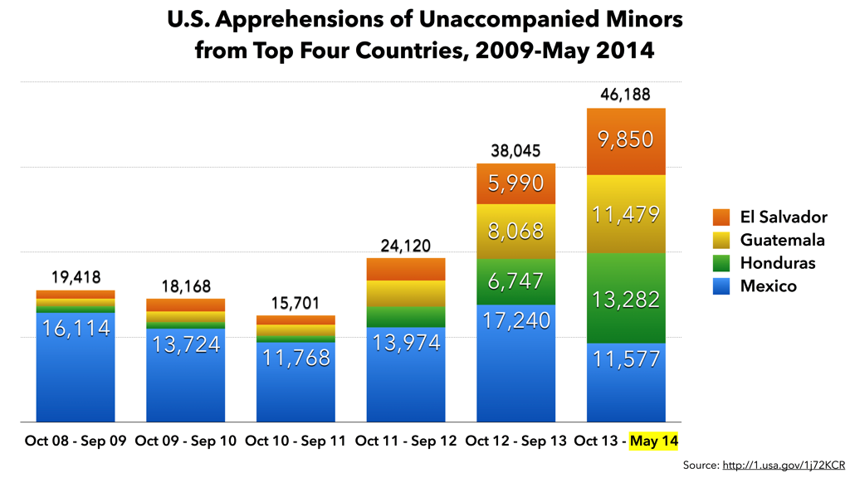
In a recent report on unaccompanied children leaving Central America and Mexico, UNHCR found approximately 56 percent of interviewed children from El Salvador, Guatemala, and Honduras with potential international protection needs. The UNHCR study found that not all unaccompanied children were seeking their parents or other family reunification, or looking for better economic opportunities. Some were fleeing violence: either violence related to organized criminal groups or domestic, intrafamily violence. The report stated that the number of asylum requests by children had increased by 432 percent. A November 2013 mission by the United States Conference of Catholic Bishops (USCCB) to Central America and Chiapas concluded that while several interrelated factors have contributed to the spike in migration of unaccompanied children, a decisive and important role has been played by “generalized violence at the state and local levels and a corresponding breakdown of the rule of law [which] have threatened citizen security and created a culture of fear and hopelessness.”
In 2012, the INM reported a 46.6 percent increase in detentions of unaccompanied migrant children, reaching 6,100 for that year. In 2013, the INM returned 8,350 migrant children to their home countries. Nearly all—8,222—were from Central America, 44 percent from Honduras.
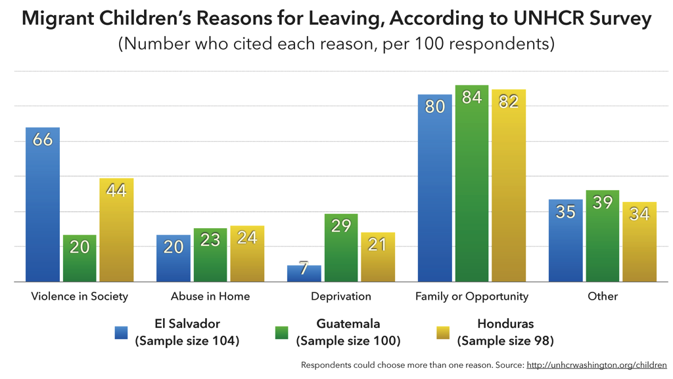
The situation of child migrants has become even more urgent due the conditions in which they travel, the way they are detained, and the procedures that are applied. In mid-May 2014 the Department of Homeland Security declared an emergency—or “four level condition of readiness”—due to high numbers of unaccompanied migrant children arriving in south Texas, which had overwhelmed the capacities of Border Patrol, other enforcement agencies, and child welfare services. On June 2, President Obama called the situation an “urgent humanitarian crisis” and requested from Congress an additional $1.4 billion in funds to assist federal agencies (it was later stated that this number could double). He appointed Craig Fugate, the head of the Federal Emergency Management Agency (FEMA), to oversee the situation.
While Mexican migrants, including unaccompanied children, are promptly returned to Mexico, Central American migrant children must be held, processed, and transferred within 72 hours to the Department of Health and Human Services. The children then remain in agency-contracted shelters until a family member, sponsor, or foster parents can be found to keep custody over them while they go through immigration court hearings. Due to the extreme violence from which many of these children are fleeing, as well as cases in which children have been victims of intrafamilial violence or human trafficking, a number of them would likely qualify to receive asylum or another permission to stay in the United States. However, these children often do not have access to lawyers, and groups that work to find pro bono legal assistance cannot meet the demand.
U.S. agencies face urgent challenges to address the wave of unaccompanied children at the border. Mexico—which has seen a less steep, but notable, increase in the number of migrant children apprehended in 2014—also faces challenges to protect this population which, like other migrants, faces multiple dangers on the journey through the country. As in the United States, migrant children arriving in Mexico—even those who would qualify for asylum—often fail to receive the protection they need.

